Module Assembly - TopCoder NodeJS Generate Reset Token API Deployment Guide

Revision History
Author | Revision Number | Date
isv | 1.0 | 03/22/2014

Deployment Instructions 3
1. Organization of Submission 3
2. Application Setup 3
2.1 Configuration 3
2.2 Build Scripts Setup 4
3. Database Setup 4
4. Deployment Instructions 4
5. Starting 4
6. Verification 4
7. Resource Contact List 7

Deployment Instructions

Organization of Submission

The submission follows directory structure provided below:

docs

Contains this document which is the Deployment Guide for the Module Assembly - TopCoder NodeJS Generate Reset Token API assembly.

tc-api

Contains the configuration, libraries, sources for TopCoder Node JS API application developed/updated in the course of this assembly. This directory replicates the application development distribution structure and includes only updated and new files.

Application Setup

The submission is expected to be deployed to the following environment:

JRE 1.7
NodeJS 0.10.21
Informix DS 11.0
Git
Python 2.7.6
Heroku

This assembly was developed against following Git commit hash:

URL: https://github.com/cloudspokes/tc-api.git
Hash: 2442eddeef448b2a4d5517724648d62a17889d11

Following revision for DB Scripts tool has been used for testing this submission:

URL: https://coder.topcoder.com/internal/database/scripts/trunk
Repository Root: https://coder.topcoder.com/internal
Repository UUID: cb5b18d2-80dd-4a81-9b1c-945e1ee644f9
Revision: 84671
Node Kind: directory
Schedule: normal
Last Changed Author: VolodymyrK
Last Changed Rev: 84662
Last Changed Date: 2014-03-25 14:33:11 -0400 (Tue, 25 Mar 2014)

Configuration

Following configuration parameter has been defined by this assembly:

Property Name | File property is stored | Example Setting
defaultResetPasswordTokenCacheLifetime | tc-api/config.js | The timeout (in milliseconds) for expiring the generated tokens for password resetting. Defaults to 30 minutes. The actual value may be set by RESET_PASSWORD_TOKEN_CACHE_EXPIRY environment variable.
resetPasswordTokenEmailSubject | tc-api/config.js | The subject for emails to be sent on generated tokens for password resetting. Defaults to 'TopCoder Account Password Reset'. The actual value may be set by RESET_PASSWORD_TOKEN_EMAIL_SUBJECT environment variable.

Build Scripts Setup

The TopCoder NodeJS API application provides the following commands which are to be used:

- npm install – installs TopCoder NodeJS API application
- npm rebuild – rebuilds TopCoder NodeJS API application
- npm test – runs Mocha-based unit tests.

Database Setup

No changes to existing database schema have been made.

Deployment Instructions

- Set up necessary infrastructure for TopCoder NodeJS API based on your environment See following page for details (click the link corresponding to your OS):
  - https://github.com/cloudspokes/tc-api/wiki/_pages
- Clone TopCoder NodeJS application from Git repository https://github.com/cloudspokes/tc-api.git to your local machine. See chapters at following page suitable for your local environment for details (click the link corresponding to your OS):
  - https://github.com/cloudspokes/tc-api/wiki/_pages
- Copy the code from tc-api directory of this submission into working copy cloned from Git repository at step above
- Set up environment variables to suit the current environment. See https://github.com/cloudspokes/tc-api/wiki/Configure-Environment-Variables
- Install TopCoder NodeJS API application using npm install command. See chapters suitable for your local environment at https://github.com/cloudspokes/tc-api/wiki/_pages for help (click the link corresponding to your OS)

Starting

- Install the TopCoder NodeJS API application
- Start ActionsHero server instance hosting TopCoder NodeJS API application (see Start Server chapter at page matching your current OS at https://github.com/cloudspokes/tc-api/wiki/_pages)

Verification

- Install redis NodeJS module with command like npm install redis

- Download and install Redis from http://redis.io/, start it and set the REDIS_HOST and REDIS_PORT environment variables to point to your REDIS server running. Note that if REDIS_HOST is set to 127.0.0.1 then ActionHero will use fake Redis server.

- Run the unit tests using command like:

node_modules/.bin/mocha ./test/test.resetPassword.js

The tests must be executed successfully:

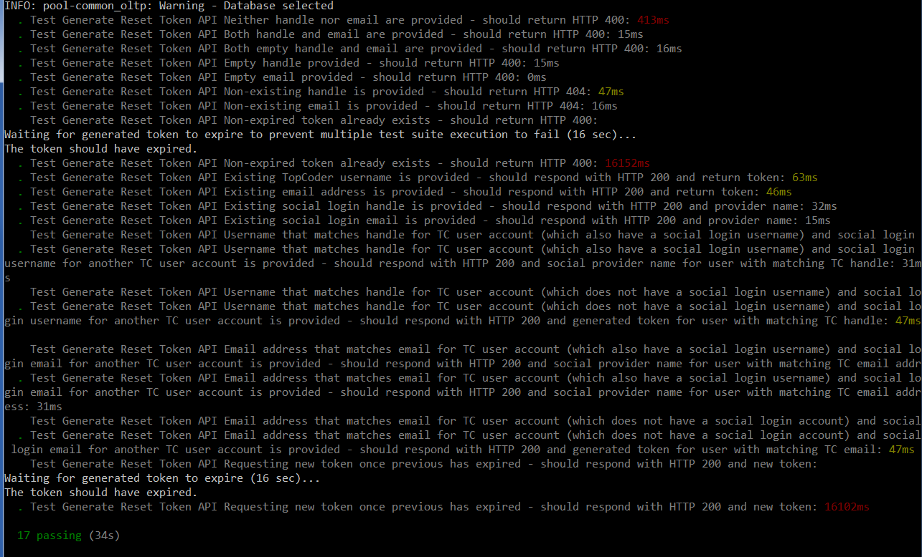

Note that one of the tests generates the token and waits until it expires. You may want to update the RESET_PASSWORD_TOKEN_CACHE_EXPIRY environment variable (see chapter 2.1) to shorten the token expiry period. For instance, you may set it to 30000 as was done for tests shown on screenshot above.

Also note that you have to re-start the application each time before running the tests because currently there is no API for deleting the generated tokens on demand.

- Setup node-jslint tool using command like npm install jslint -g and check formatting for the updated code using commands like:

jslint --nomen actions/generateResetToken.js
jslint --nomen common/stringUtils.js
jslint --nomen test/test.generateResetToken.js
jslint --nomen config.js
jslint --nomen routes.js

There must be no code formatting errors displayed:

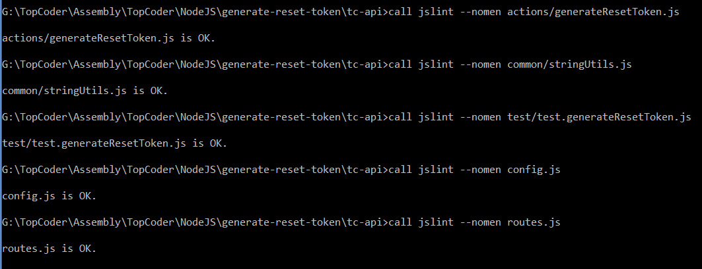

- Deploy application to Heroku by following the instructions at https://github.com/cloudspokes/tc-api/wiki/Heroku-Deployment-Guide

The application must be deployed successfully.

- To verify the API documentation, go to http://apiary.io, register and create own account, open Blueprint Editor and copy the content of tc-api/apiary.apib file from submission to editor and click Preview button.

The API documentation must be displayed successfully.

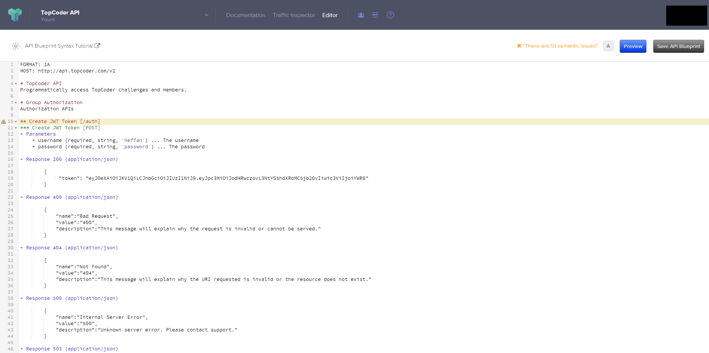

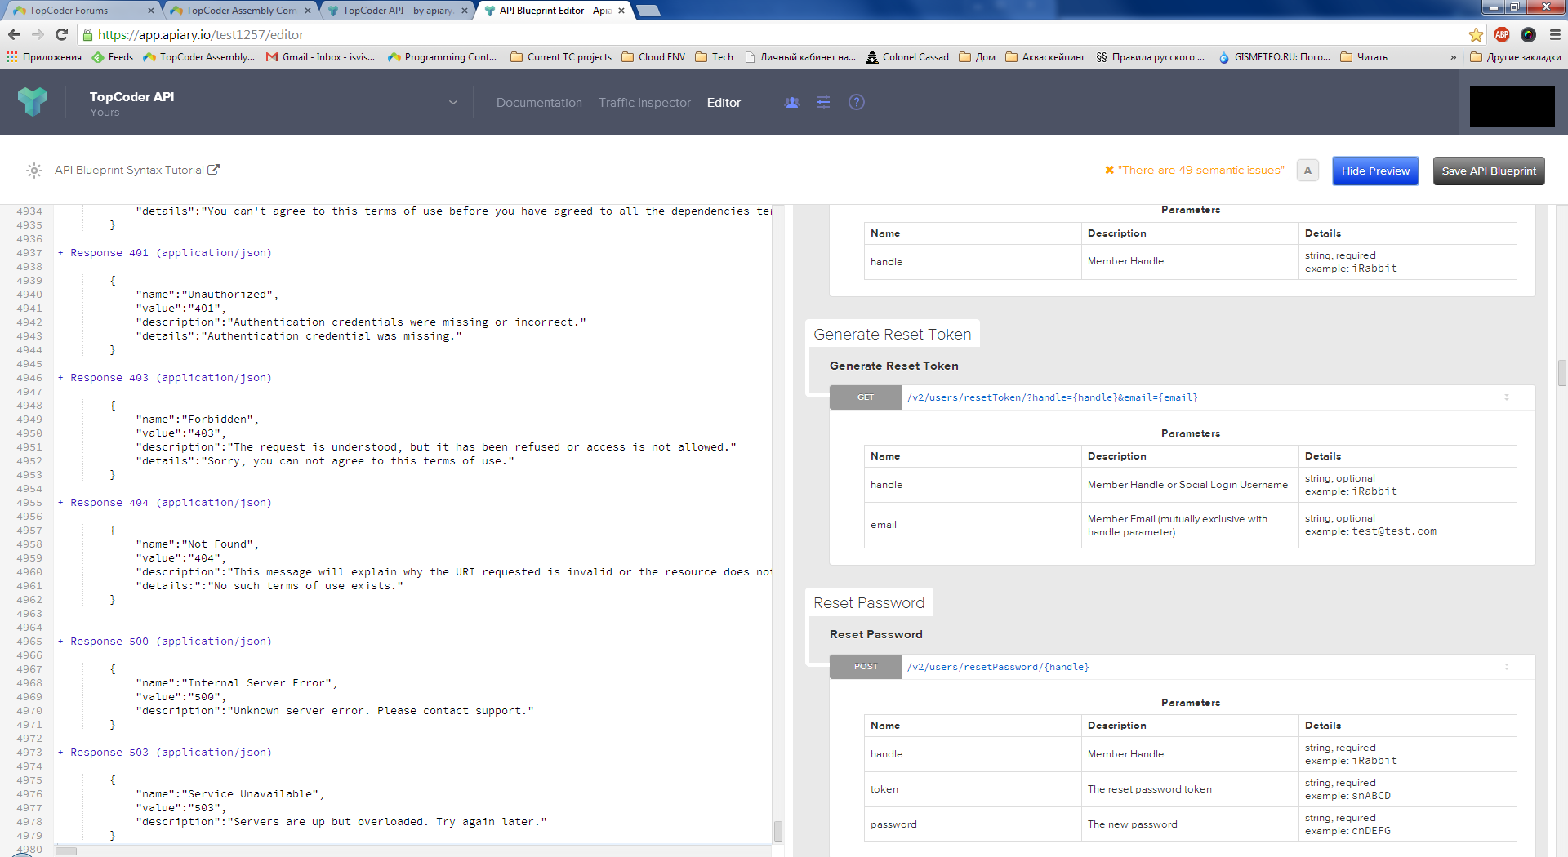

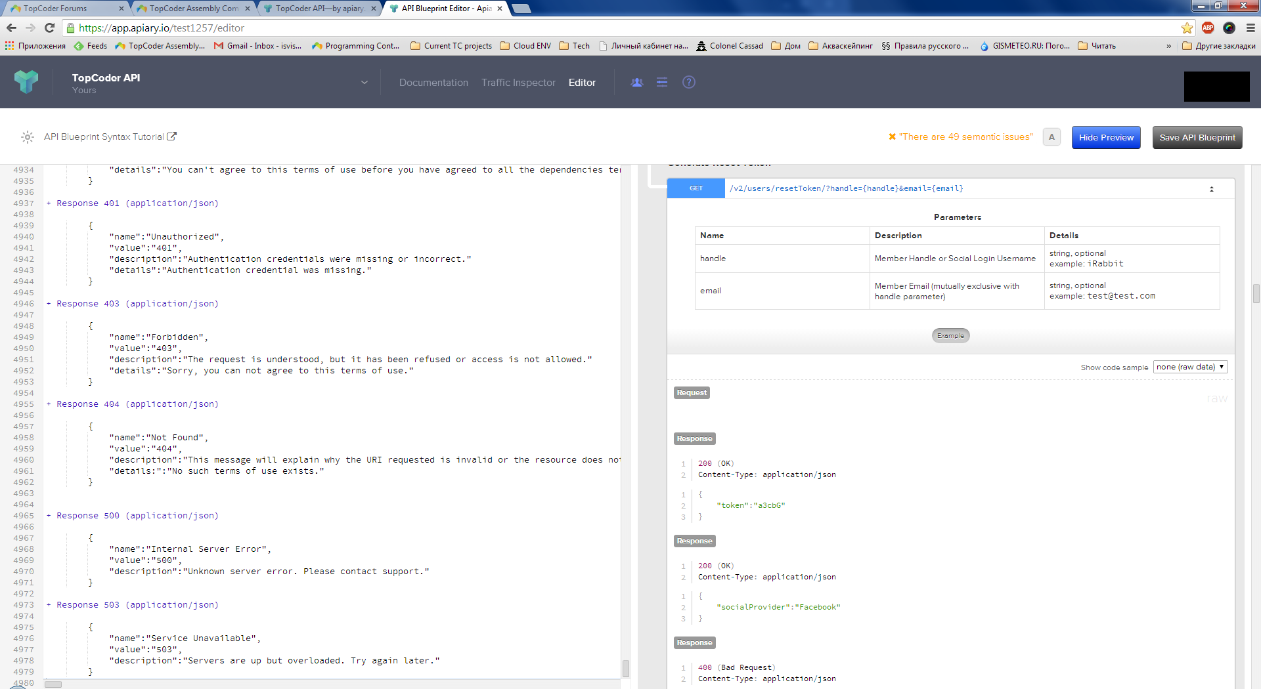

- To test the application from browser open URL like http://localhost:8080/v2/users/resetToken?handle=heffan

The application must respond correctly.

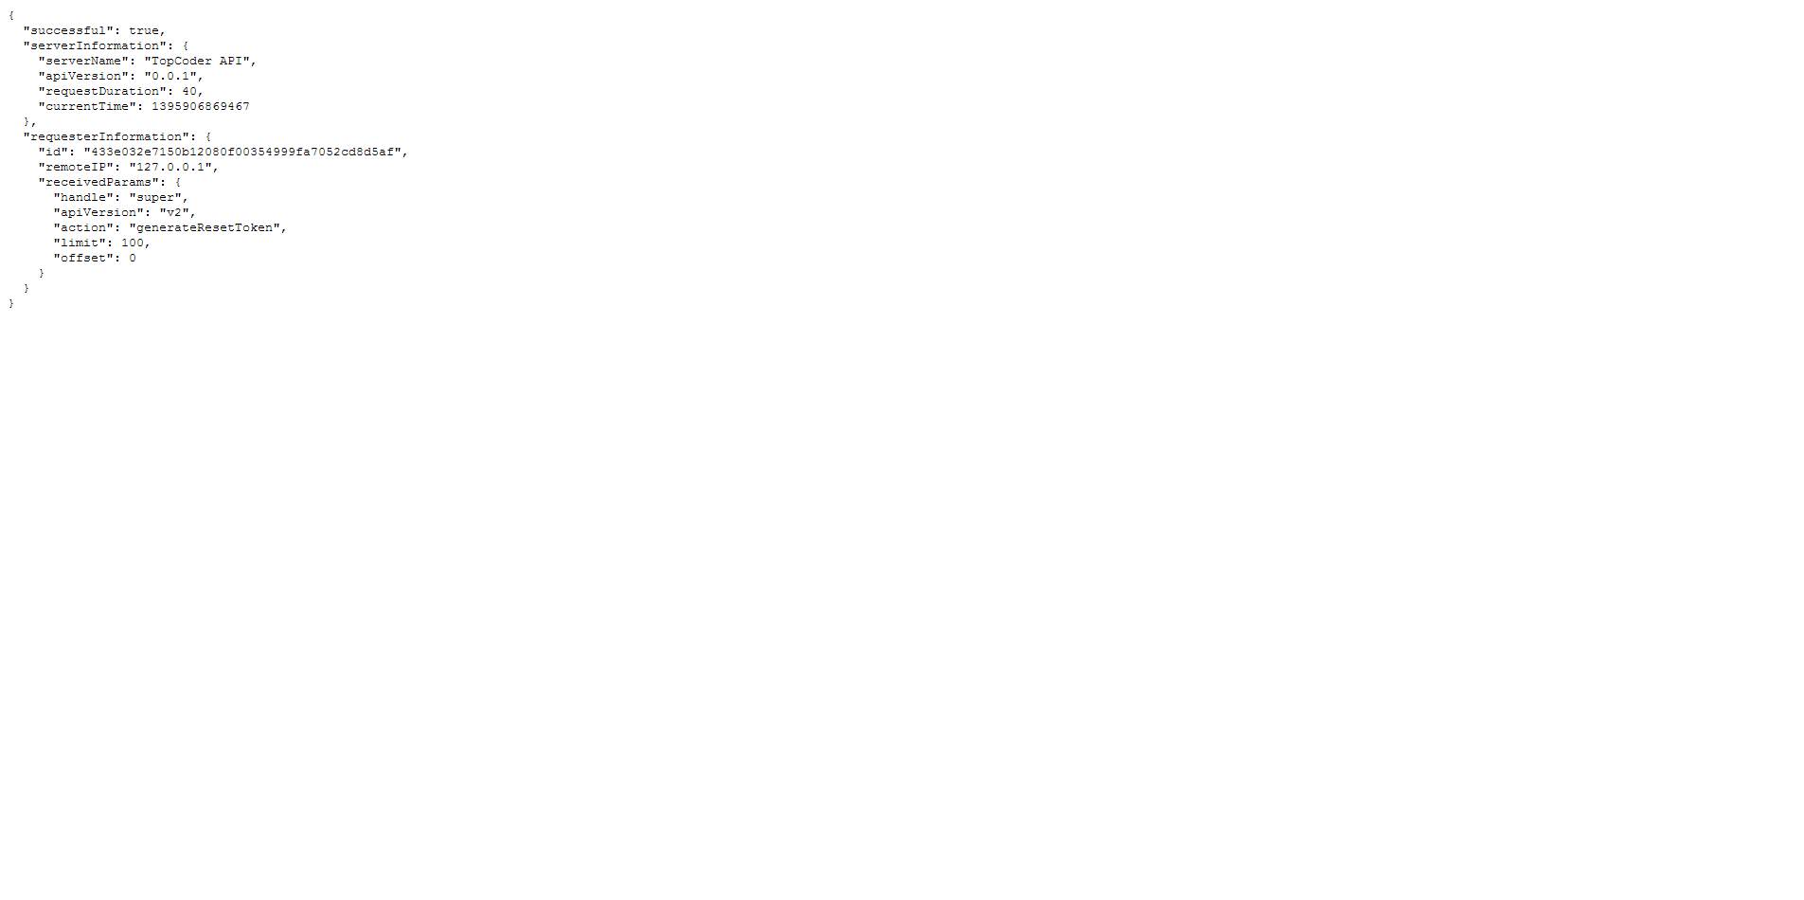

- Check the applicaiton log.

There must be a message on sending the email

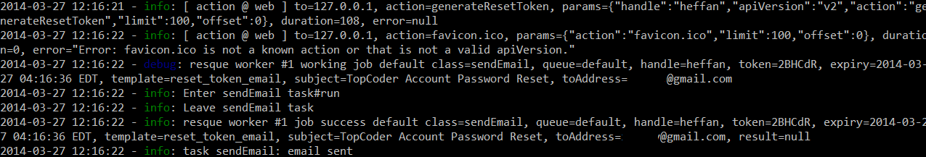

- Before the token expires re-fresh same page in browser

The application must respond correctly.
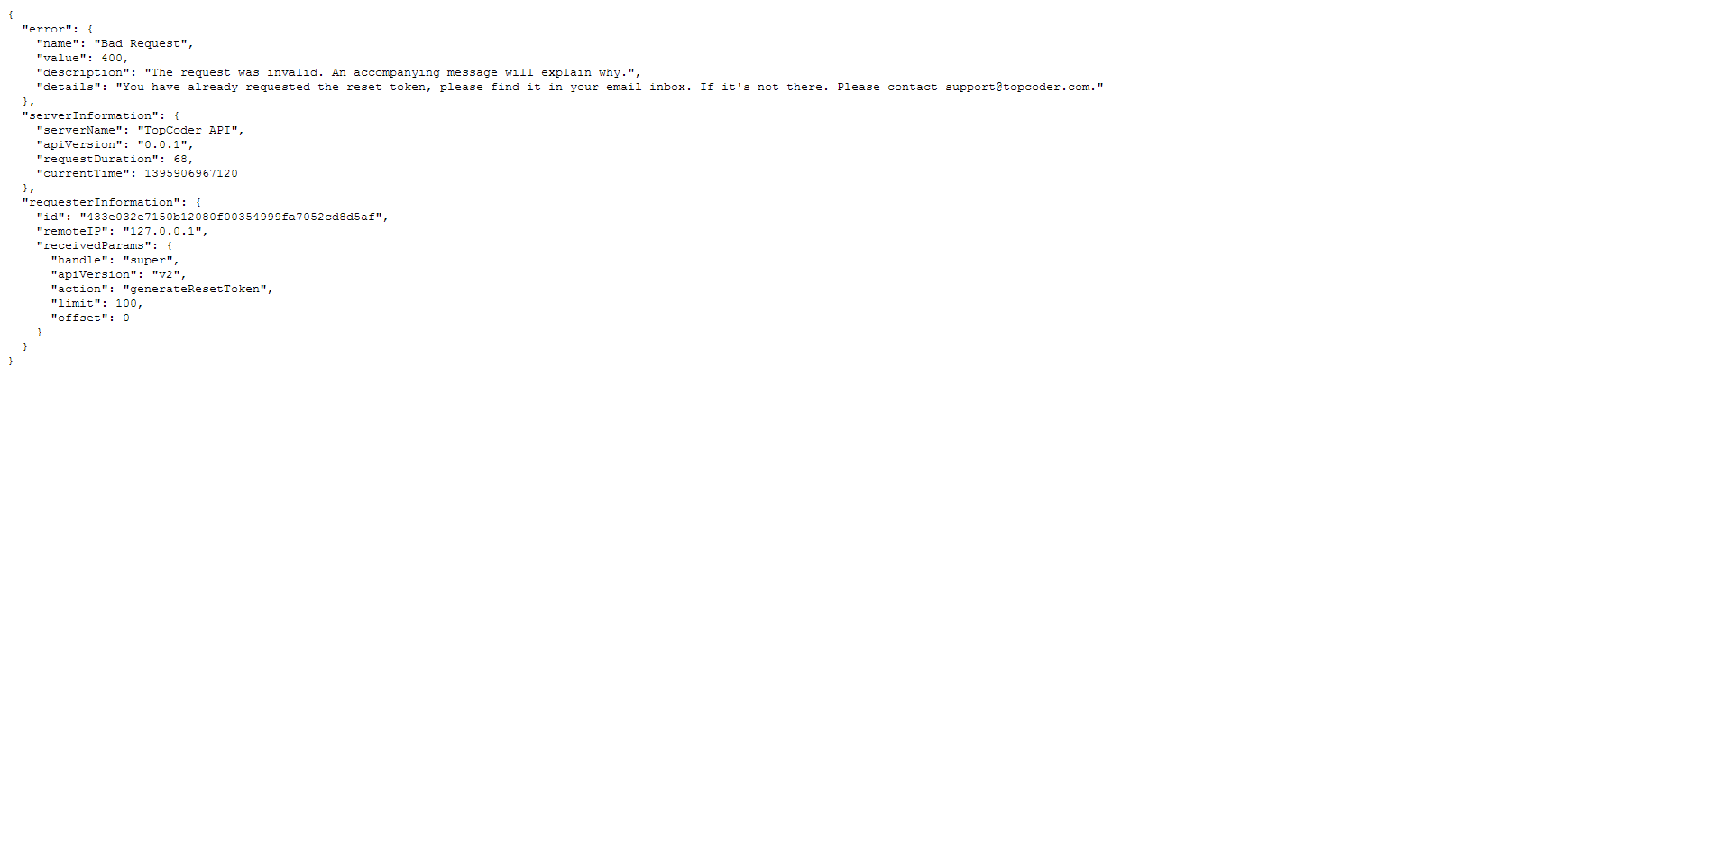

Resource Contact List

Name | Resource Email
isv

